[](https://www.kaggle.com/c/the-analytics-edge-mit-15-071x)

[The Analytics Edge (15.071x)](https://www.kaggle.com/c/the-analytics-edge-mit-15-071x)

**8.2 days to go**

Monday, April 14, 2014

Monday, May 5, 2014

Knowledge • 1,057 teams

Dashboard

* [Home](https://www.kaggle.com/c/the-analytics-edge-mit-15-071x)
  + [Data](https://www.kaggle.com/c/the-analytics-edge-mit-15-071x/data)
  + [Make a submission](https://www.kaggle.com/c/the-analytics-edge-mit-15-071x/submit)
* Information
  + [Description](https://www.kaggle.com/c/the-analytics-edge-mit-15-071x)
  + [Evaluation](https://www.kaggle.com/c/the-analytics-edge-mit-15-071x/details/evaluation)
  + [Rules](https://www.kaggle.com/c/the-analytics-edge-mit-15-071x/rules)
  + [Timeline](https://www.kaggle.com/c/the-analytics-edge-mit-15-071x/details/timeline)
* [Forum](https://www.kaggle.com/c/the-analytics-edge-mit-15-071x/forums)
* [Leaderboard](https://www.kaggle.com/c/the-analytics-edge-mit-15-071x/leaderboard)
* [My Team](https://www.kaggle.com/c/the-analytics-edge-mit-15-071x/team)
* [My Submissions](https://www.kaggle.com/c/the-analytics-edge-mit-15-071x/submissions)

[Leaderboard](https://www.kaggle.com/c/the-analytics-edge-mit-15-071x/leaderboard)

1. Ozzy Johnson
2. MartinM
3. erbose
4. FrancescaMa
5. Telesphore
6. Robert Ko
7. KrisChris
8. ardupuis
9. Ernesto Cordova
10. twinkletoes

[Forum (119 topics)](https://www.kaggle.com/c/the-analytics-edge-mit-15-071x/forums)

* [Data preparation for glmnet](https://www.kaggle.com/c/the-analytics-edge-mit-15-071x/forums/t/7902/data-preparation-for-glmnet/43180#post43180)

12 seconds ago

* [gbm prediction out of range](https://www.kaggle.com/c/the-analytics-edge-mit-15-071x/forums/t/7895/gbm-prediction-out-of-range/43177#post43177)

32 minutes ago

* [Guidance please](https://www.kaggle.com/c/the-analytics-edge-mit-15-071x/forums/t/7898/guidance-please/43172#post43172)

53 minutes ago

* [What next](https://www.kaggle.com/c/the-analytics-edge-mit-15-071x/forums/t/7780/what-next/43171#post43171)

1 hour ago

* [Cor function](https://www.kaggle.com/c/the-analytics-edge-mit-15-071x/forums/t/7900/cor-function/43170#post43170)

1 hour ago

* [CV vs LB](https://www.kaggle.com/c/the-analytics-edge-mit-15-071x/forums/t/7897/cv-vs-lb/43167#post43167)

1 hour ago

teams

players

entries

[Competition Details](https://www.kaggle.com/c/the-analytics-edge-mit-15-071x) » [Get the Data](https://www.kaggle.com/c/the-analytics-edge-mit-15-071x/data) » [Make a submission](https://www.kaggle.com/c/the-analytics-edge-mit-15-071x/submit)

**This competition is private-entry.** You've been invited to participate.

Learn what predicts happiness by using informal polling questions.

(Please note: this competition is only open to students of <https://www.edx.org/course/mitx/mitx-15-071x-analytics-edge-1416>)

What predicts happiness? In this competition, you'll be using data from Show of Hands, an informal polling platform for use on mobile devices and the web, to see what aspects and characteristics of people's lives predict happiness.

Show of Hands has been downloaded over 300,000 times across Apple and Android app stores, and users have cast more than 75 million votes. In this problem, we'll use data from thousands of users and one hundred different questions to see which responses predict happiness.

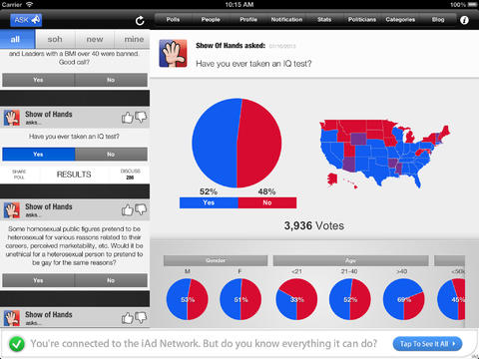

**Acknowledgements**

This competition is brought to you by 15.071x, edX, and Show of Hands.

Started: **11:59 pm, Monday 14 April 2014 UTC**   
Ends: **11:59 pm, Monday 5 May 2014 UTC (21 total days)**